*Section 2 - Investigation*

Investigation of the current system

Following the identification of the problem and the displaying of my proposed solution, I now will look at examining the current system that is being used at Meigh Pharmacy. The investigation will be conducted using various reliable methods such as structured interviews, questionnaires, and document sampling. Fortunately, I was able to conduct an on-site observation which made collecting the data for the investigation easier and more reliable.

This first method for collecting data, that I used, was a structured interview with Richard Garvey, the Senior pharmacist at Meigh Pharmacy. I feel by interviewing the pharmacist I will receive first-hand insight into the day-today needs of the pharmacy, how the current system operates and what actually occurs during an average workday in the pharmacy. Richard will be answering pre-prepared questions in the interview, however there will be opportunity for him to give his own thoughts on the current system in use.

To go along with the qualitative data gathered in the structured interview, I have also decided to gather extra information from company documents, which in turn will give me a better idea of the current system. To do this I requested that Richard provide me with internal paperwork and logs in order to get a real understanding of the current system.

I have also decided to use a google questionnaire that has been distributed to all employees of the pharmacy via email.

Advantages and Disadvantages of each Method

|  |  |  |
| --- | --- | --- |
| Method | Advantage | Disadvantage |
| Structured Interview | Through pre-prepared questions we will be able to get exact data on specifics such as the input of the current system | The wording of the question may lead to bias towards one opinion, which is an issue as it would make the data invalid |
|  | Using standardized questions allows for comparisons to be made between different employees answering the same question | Structured interviews are very time consuming compared to other methods |
|  | We can use open questions in order to allow for a variety of answers, that include personal views of the current system. | Interviews require a lot of preparation such as setting a date, time and location of the interview itself, along with printing answering sheets and writing transcripts of the interview. |
| Document Sampling | Gives the most valid outlook on the current system through the collection of paperwork and Medical scripts. | Some documents may be too vague in giving an idea of the current system, and therefore will waste time. |
| Questionnaire | Can be done electronically and therefore is very easy to set up and distribute | Easy to lie and be dishonest on the questionnaire |
|  | Cheap and doesn’t cost any extra to set up | Questionnaires can be inflexible and there may limit the potential depth of answers that can be acquired. |
|  | Questionnaires can be anonymous and therefore can allow for self-conscious employees to answer honestly without concern |  |
| Desk-Based Research | Saves time and is relatively inexpensive | Limited control over the quality of the data and its accuracy |
|  | Allows me to see what makes certain systems work and possibly implement their features into my own solution | May contain bias towards specific systems or companies |

Structured Interview

Date – 23/02/24

Name – Richard Garvey

Role in pharmacy – Head Pharmacist

Q1. Currently how many NHS Approved Pharmacists are employed?

A1. There are Two registered NHS pharmacists currently employed by Meigh pharmacy. One with over 17 years’ experience, and the other a recent graduate from Queens University Belfast.

Q2. Currently what data is stored on each pharmacist?

Q2. Currently the Pharmacists data recorded is:

* Full name
* Address
* Mobile Number
* Appointments
* Experience

Q3. How is pharmacist data stored currently?

A3. Pharmacist data is stored in with all other data is a large file cabinet located in the basement of the Pharmacy.

Q4. How do you ensure the security and confidentiality of pharmacist data currently?

A4. The only current security measures in place are that the file cabinet is locked with a Grade 1 lock that requires a key that is in possession of myself and the owner of the pharmacy. The basement where the cabinet is located is also locked with an electronic lock that requires a four-digit pin that only myself, and the owner are aware of.

Q5. Can you explain the process of inputting or updating pharmacist data?

A5. The pharmacist’s data is inputted by writing their details onto a form and this is added to the file cabinet. To update pharmacist data their current form is removed from the cabinet, certain details are copied over to a new form, other updated details are added to this new form, and the original form is destroyed while the new form is added to the cabinet.

Q6. How do you handle pharmacist data disposal?

A6. Their data is removed from the cabinet and destroyed by means of incineration. If the pharmacist leaves the company, we hold the data for 18 months for legal reasons and then the data is physically destroyed.

Q7. How does each pharmacist access their appointments?

A7. Once an appointment is booked, we add the appointment onto a calendar located in the back room of the pharmacy where the pharmacist can go look at their daily appointments.

Q8. Do you believe the current system is efficient enough for the pharmacy? If not please state reasons why.

A8. Absolutely not. The current system wastes time, resources and money. It is completely outdated and has led to appointment mix-ups which cannot be allowed in such an important business such as a pharmacy. Personally, I believe the current system should be completely revamped in order for the pharmacy to survive.

Name – Melissa O’Malley

Role – Retail assistant

Q1. How many retail staff our employed at Meigh pharmacy?

A1. Just one, myself.

Q2. What does your role entail?

A2. Currently my role involves serving patients medicine, serving customers of the pharmacy shop, organizing scripts and maintaining overall cleanliness in the pharmacy.

Q3. What data is stored on Retail staff

A3. Currently the data stored on retail staff is:

* Full name
* Date of birth
* Address
* Phone number
* Experience

Q4. When you joined the pharmacy, how was data stored on retail staff?

A4. When I joined the pharmacy, I was given a form, similar to the rest of the staff, to which I filled in my details and my form was added to the file cabinet in the basement.

Q5. How is retail staff data updated?

A5. Again, similar to the pharmacist data, a new form is filled out with existing and updated details, then the old form is destroyed after 18 months, and the new form is added to the file cabinet.

Q6. How is retail staff data deleted?

A6. The old form is removed from the cabinet by a trusted member of staff and then destroyed via incineration.

Q7. Do you feel that there is effective communication between the retail staff and the rest oof the pharmacy staff when it comes to serving the correct medication and scripts to patients?

A7. At the minute I believe there is appropriate communication between us, however one problem is that stock levels of specific medicine to be served through scripts to patients is all over the place due to the stock levels being stored on a paper sheet. It has led to the wrong medicine being given out to the wrong patients.

Q8. Have you encountered any issues when it comes to using the system for retail purposes?

A8. Yes, similar to the medicinal stock issues, the stock levels of the retrial items in the pharmacy shop are also paper based. This has led to miscalculations in stock levels and overall loss of profit for the pharmacy.

Q9. Is there anything you would like added to the pharmacy?

A9. Possibly a more fluent system that works well and is more efficient when regarding stock levels of medicine and retail items

Name – Charles Larkin

Role – pharmaceutical assistant

Q1. Currently how many patients are registered with the pharmacy?

A1. Currently 150 patients are registered with the pharmacy, local and outside of the community.

Q2. How many patients do you serve/ have appointments with daily?

Approximately we have a daily intake of 20 patients for medicine collections and around 6-7 appointments a day, depending on the two pharmacists working hours.

Q3. What details are stored on patients?

A3. Currently the data stored on patients is:

* Full name
* NHS Number
* Date of birth
* Appointment number
* Mobile number
* Address (in order to verify patient identity)

Q4. Where is patient data stored?

A4. Patient data is stored in the same set of filing cabinets as the rest of the pharmacy’s data, in the basement of the pharmacy.

Q5. Have you experienced any difficulties with patient data?

A5. Yes, due to the reliance on forms and the patients hand writing, sometimes patient data cannot be read and must be requested again, leading to delays and time lost. Patient data organization has also become very inefficient, especially with the number of patients currently held, due to the order of the forms not being in alphabetical order.

Q6. How is patient data added, updated and deleted?

A6. Currently Patients fill out a form and this is taken and added to the set of file cabinets. To update patient data a new form is filled out, similar to the staff data, and the old form is removed and destroyed. To delete patient data their form is removed from the file cabinet and is destroyed via incineration due to confidentiality reasons.

Q7. Is there anything you would personally like added to the new system?

A7. Yes, I would like a more efficient and simpler way to store patient data as the current system is way too inefficient and outdated. The new system must allow for a larger influx of patient data to be stored and up-to-date.

Desk based research

To begin my desk-based research I took an in-depth look into similar systems to my solution. This lets me see what features I may want to include in my solution and, possible weaknesses in other solutions in order for me to make a complete and efficient system. There are two pieces of pharmacy software that I will be looking into: Abacus Pharmacy software and Visual SuperScript. They both aim to make pharmacy’s run more efficiently by providing a digital online work environment.

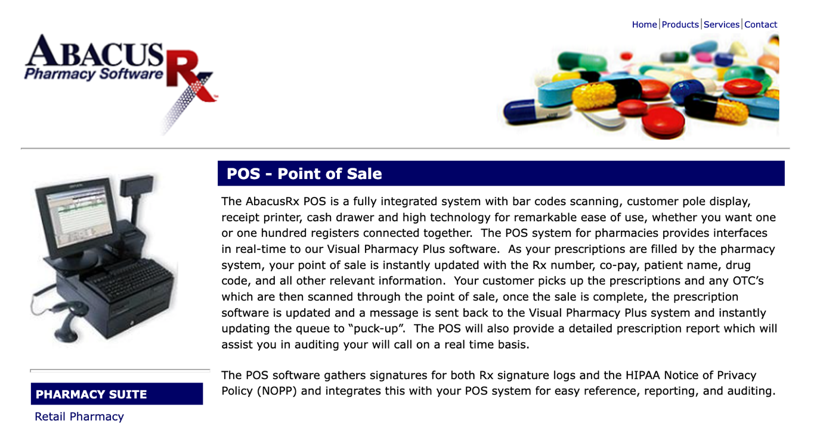

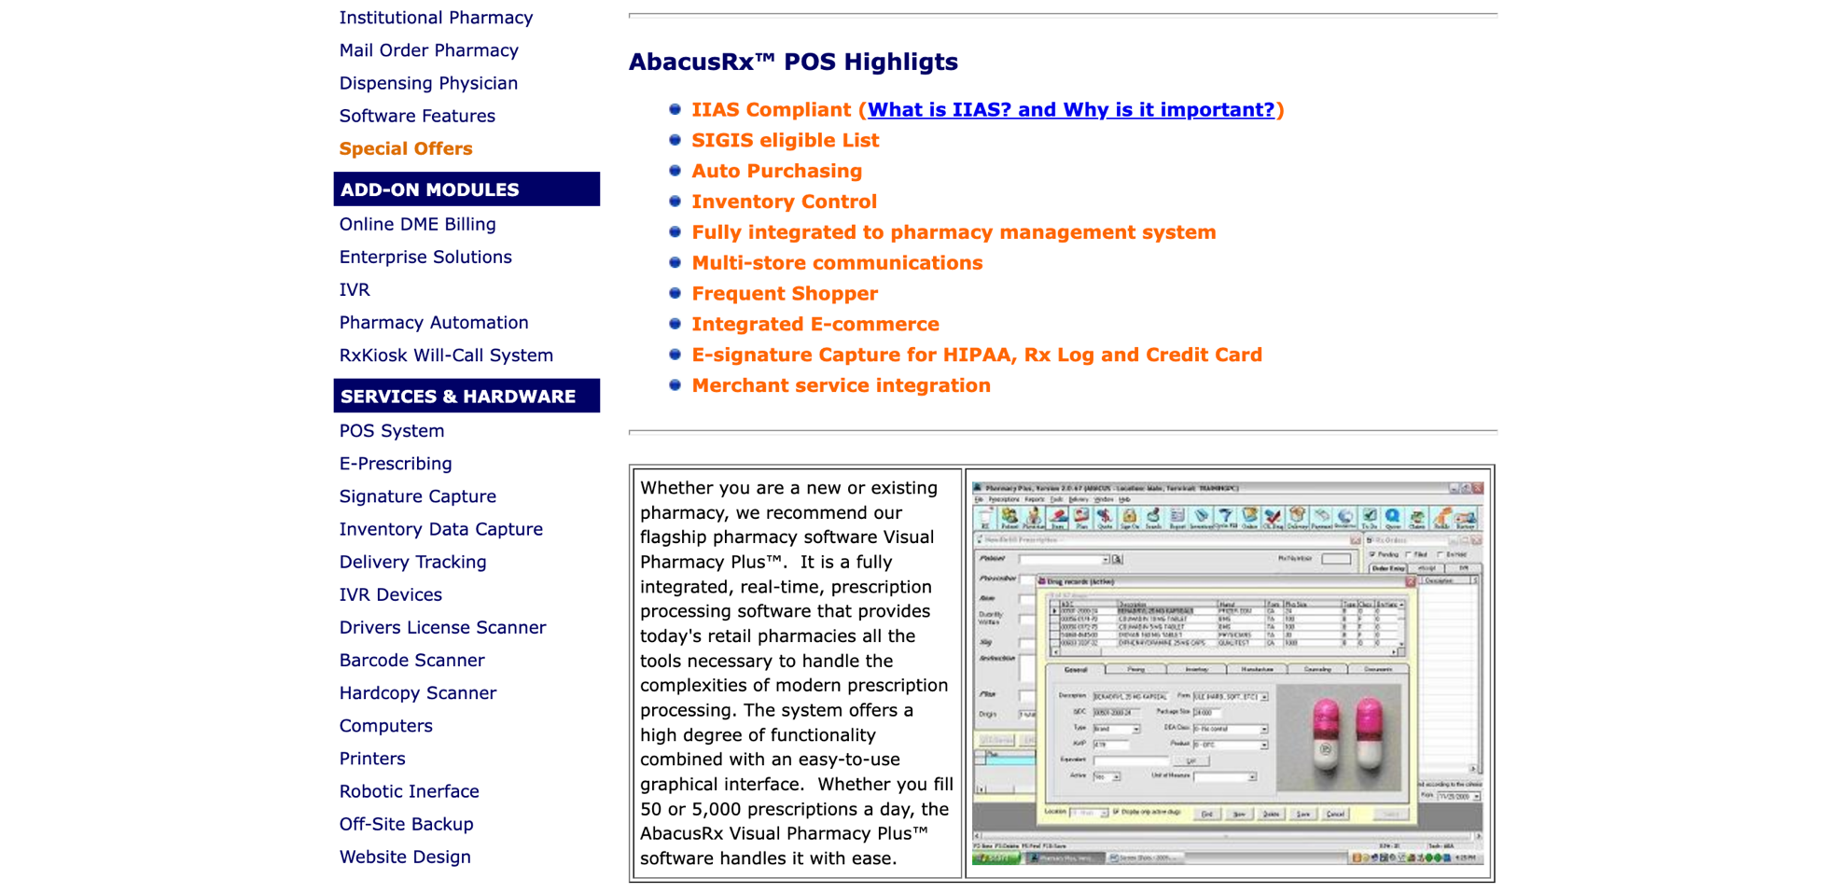

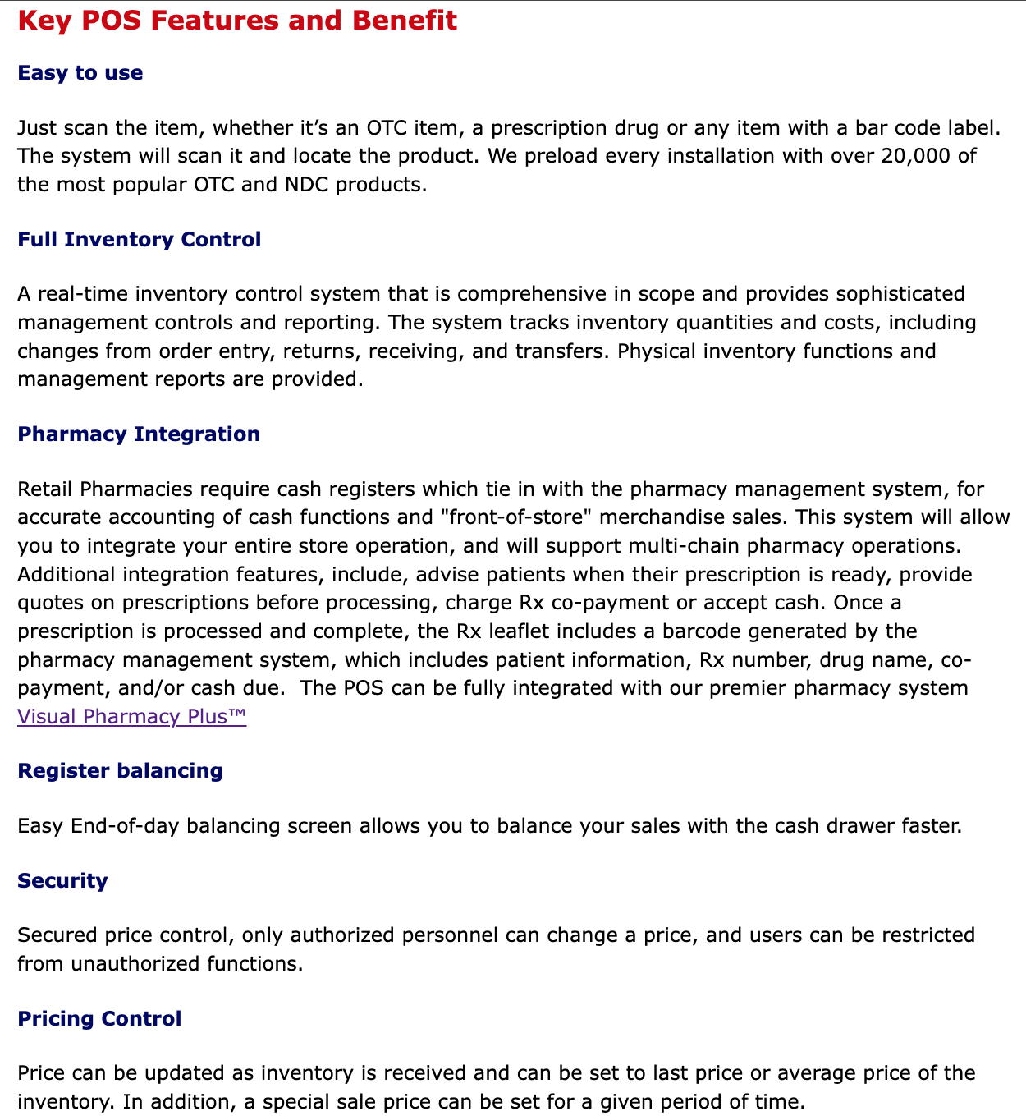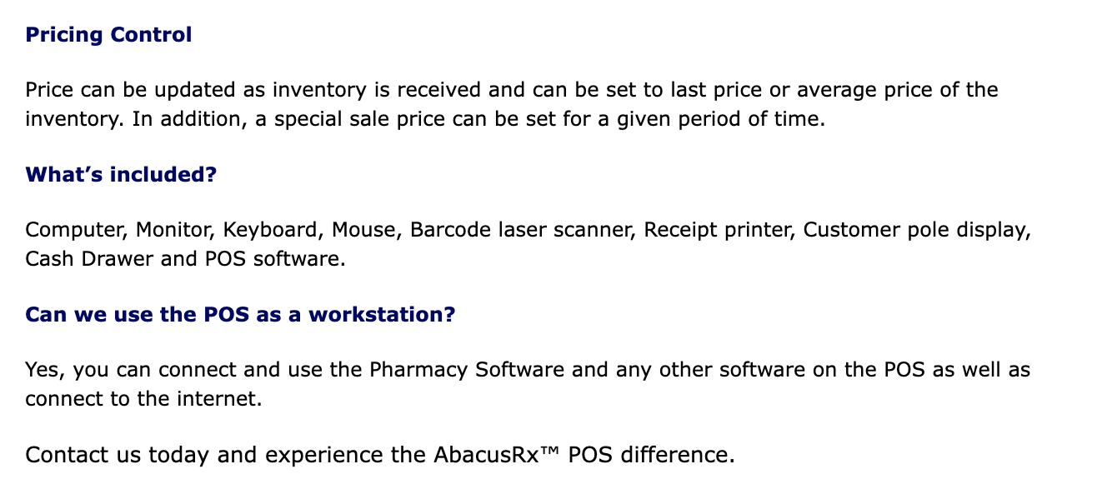

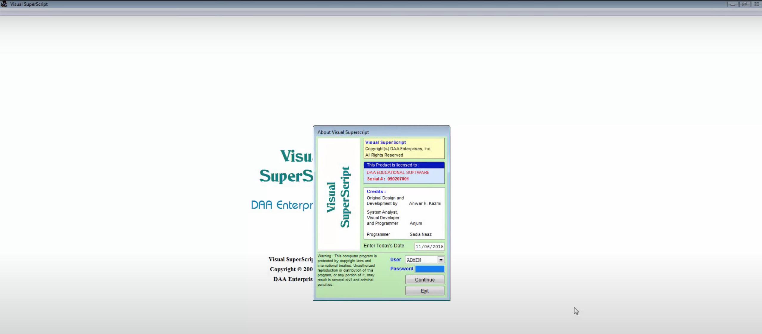

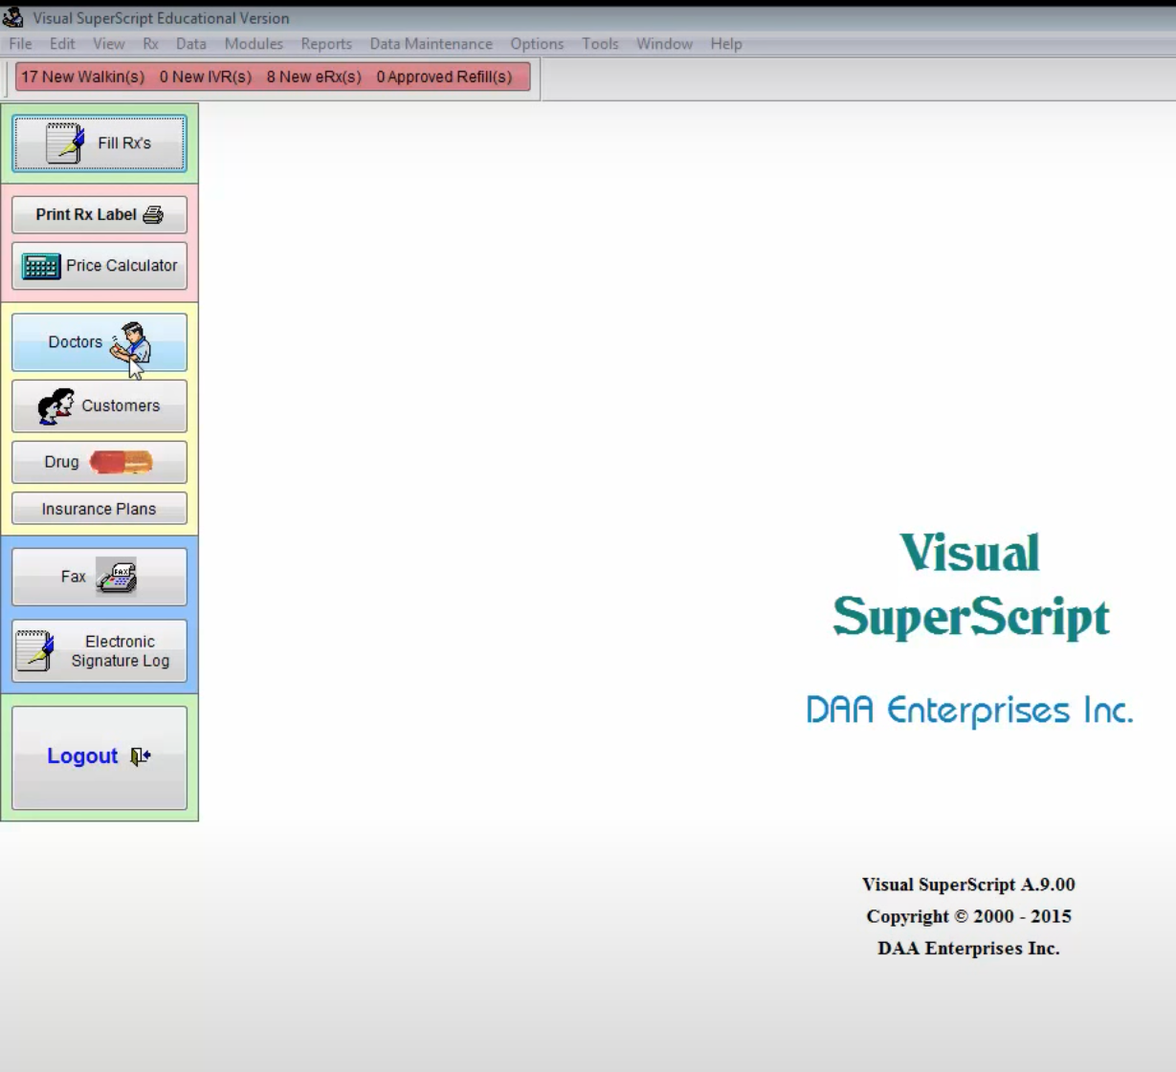

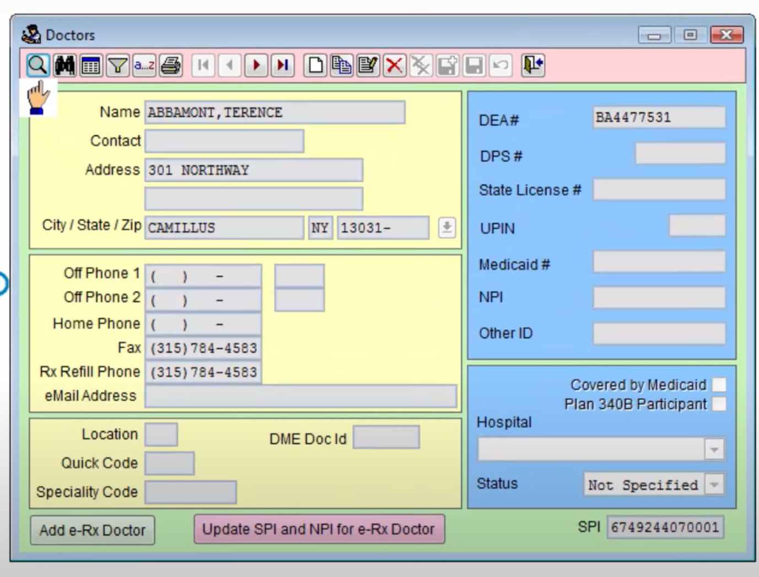

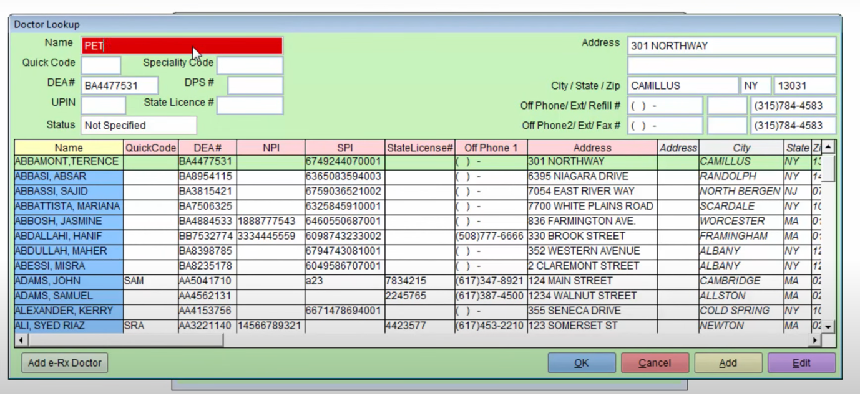

Summary of Desk based Research

After conducting desk-based research, I have compiled the following points on each system:

Both systems use very modern and up-to-date Menu systems that are very easy to use and would require little training. The menus seem very easy to navigate and if I decided to add this to my own system it would make data entry and access much more efficient and time-saving. It would also allow me to add new features quite easily if in the future I find something that could further develop the efficiency of my system.

The AbacusRX POS software tracks, in real time the inventory of certain medicine and this allows for up-to-date stock levels. This is something I would try to implement into my system in order to have the correct medicine available for patients when it is needed.

Both systems use a slimline and eye-catching GUI interface. This type of interface is a lot easier to understand than command line interface. This would be very important when it comes to data entry as incorrect data entry by a pharmacist or an assistant could lead to complications, costing the pharmacy money and time but more importantly endangering the patient’s physical health. That is why I would choose a GUI when deciding the interface of my solution.

Both systems as well seem to be color coded. This is a feature I may want to add to my own proposed solution as not only is eye-catching, it further helps with the efficiency of the system while adding only minor training. It would also reduce the risk of incorrect data being entered as certain colors, such a red, are naturally associated with seriousness, and therefore this would naturally indicate to the user that if an icon or button was red, it is of high importance.

The Visual Superscript software also has integrated a price calculator into their system. This may be something I would like to add to the system as it would further develop and grow the overall efficiency of the business, while keeping medicine costs up-to-date, while also making tracking profit a lot easier.

As there is the possibility of new features being added, I will have to program in a way that is smart and optimizes my resource usage as I want to ensure that my solution will be able to be used on older systems, such as those at Meigh Pharamcy, but also the latest systems that are being released.

Both systems have also optimized their resource usage by having all the services and necessities in one software application, and I would like to follow the same strategy in my own solution, in order to save time from not having to switch to different software’s for certain services

Questionnaire

To further my research, I conducted a questionnaire with a group of four staff from Meigh Pharmacy, located below are my results:

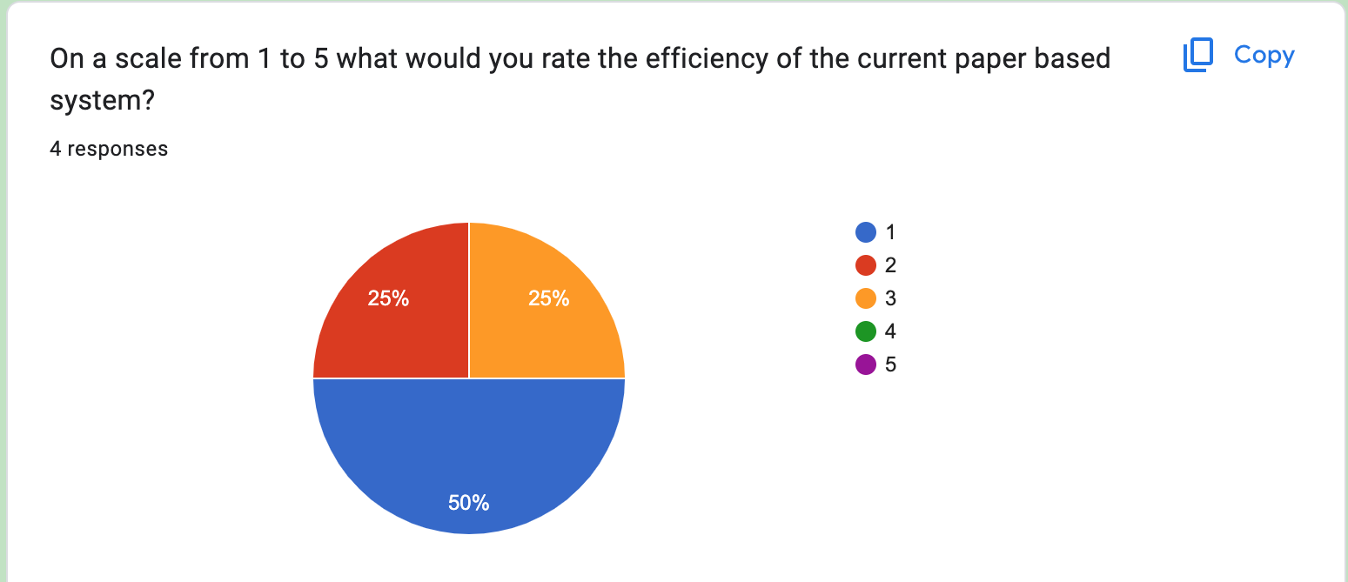

As you can see my first question proposed to the staff asks them to rate the efficiency of the current system in place at the pharmacy. We can see that most of the staff answered quite negatively with two out of the four rating it 1/5 and the other two rating it no higher than 3/5.to further add to this and gather more feedback I then asked the staff how the system’s efficiency could be improved.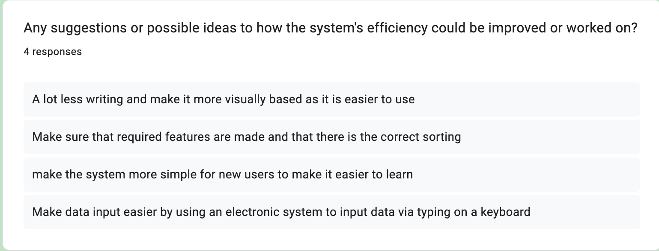

All of these suggestions are acceptable as to how the efficiency could be improved as :

* Older staff at Meigh Pharmacy may want a more visual and less typing based system as it would be a lot simpler to learn and use, requiring minimal training saving time and money.
* Making the correct features first would give the system a good foundation that could possibly be improved on through the use of updates, while having the most important features implemented well.
* A simpler system through the use of GUI and buttons would not only make the system more eye-catching but also easier to learn, requiring less training and being more time efficient
* An electronic system is vastly more efficient than a paper-based system due to it being more modern and compatible in todays technological world. It is also a lot more time efficient compared to a paper-based system as typing saves time. Less data errors would occur as well due to not having different hand writing like that in a paper-based system.

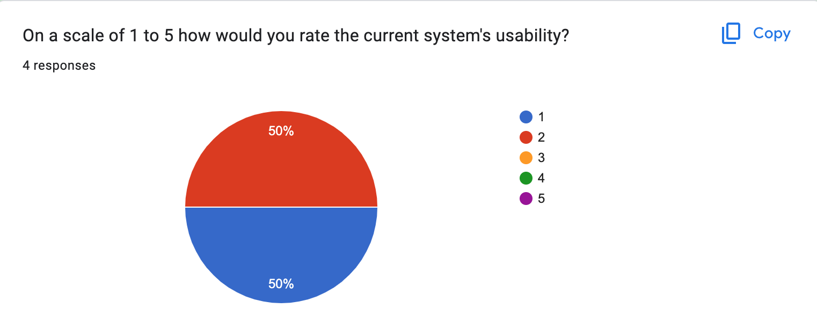

As we can see the staff have also rated the current systems usability quite low out of five, with two rating it a 1/5 and the other two rating it a 2/5. This seems to match the views of the systems efficiency.

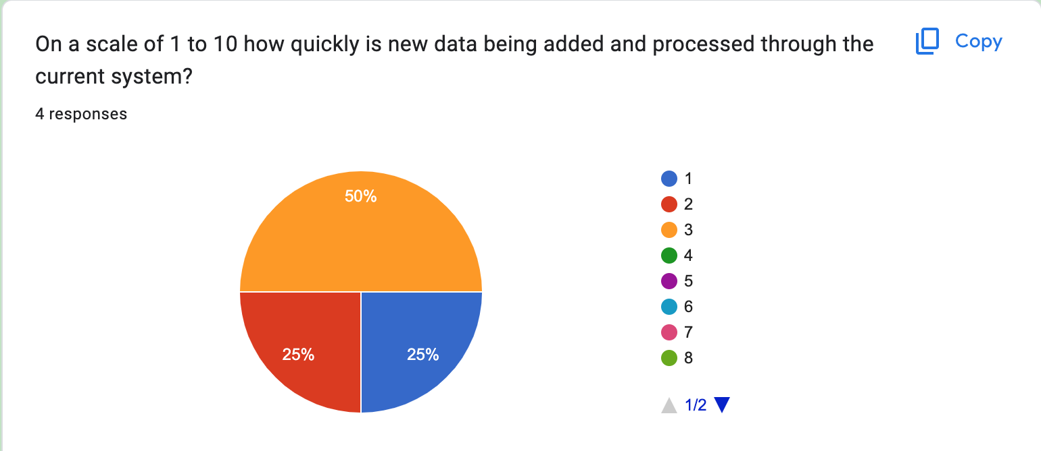

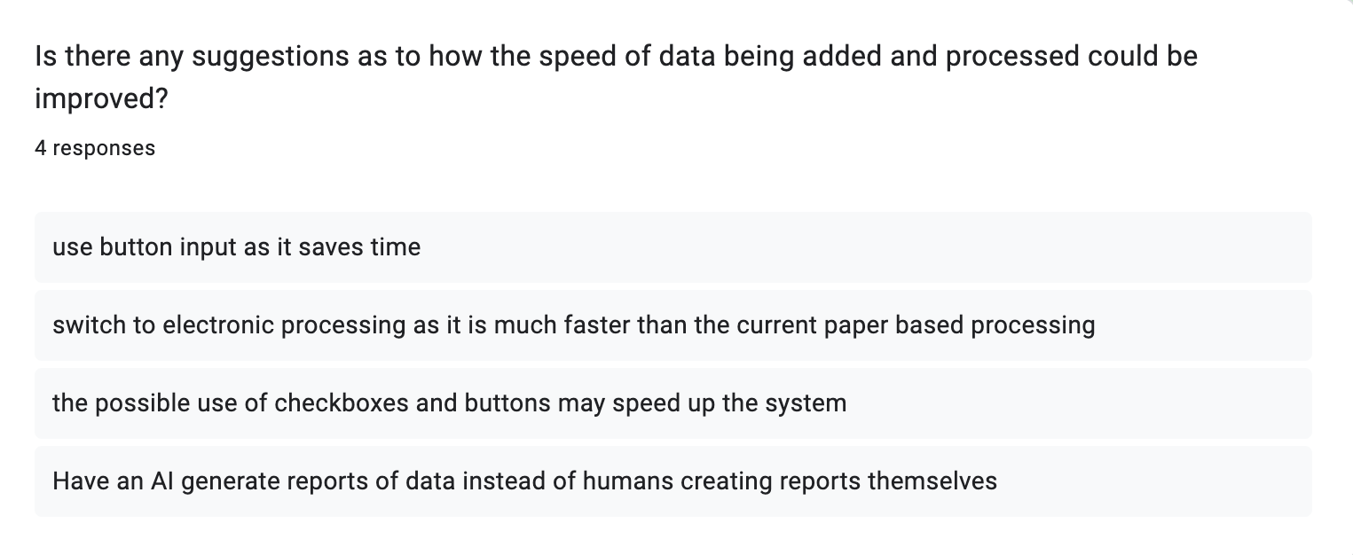

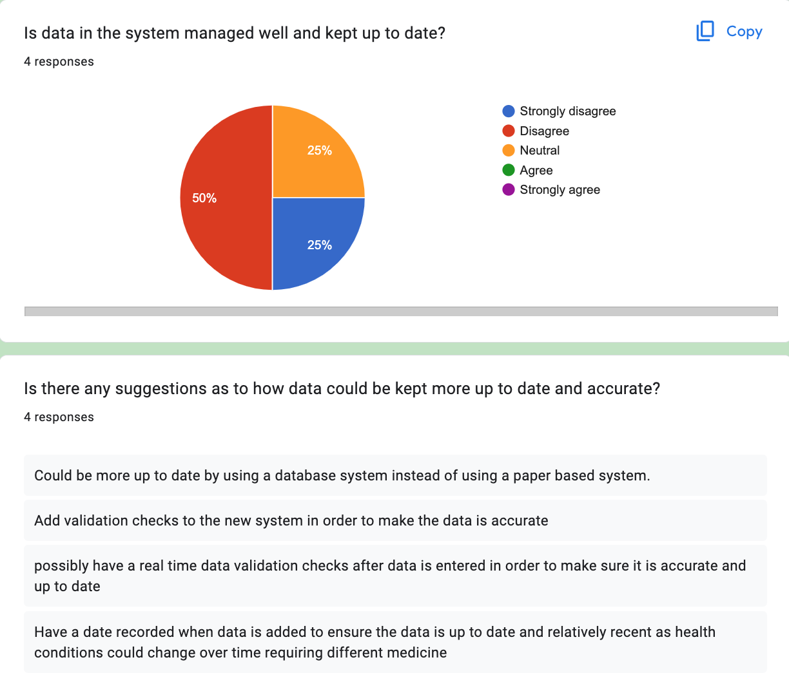

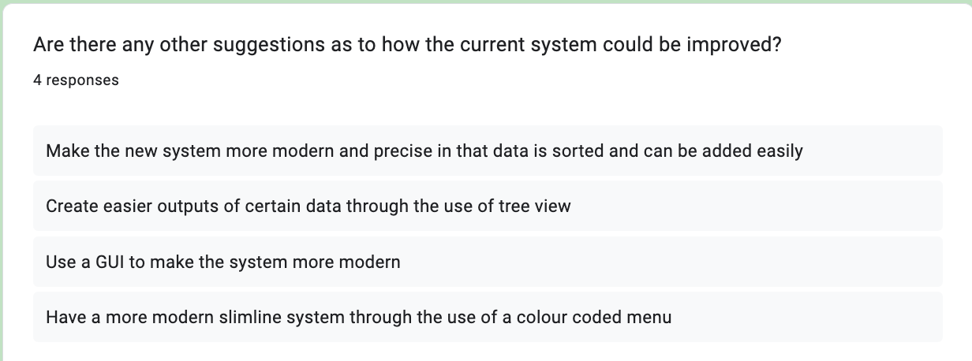

Summary specification

The overall aim of my solution is to improve the upon the currently limited and inefficient paper-based system’s functionality in a new, sleek and modern system that gives users certain vital features that are necessary for a NHS Pharmacy to be run correctly. Listed below is the main goals that I would like to hit with my proposed solution in order for future updates to be viable.

Pharmaceutical assistant

* Add new Pharmacist details to the system
* Delete Pharmacist details
* Update Pharmacist details
* Archive Pharmacist details
* Add new patient details to the system
* Delete current patient details
* Update current patient details
* Archive current patient details
* View all Pharmacy Bookings
* Create new Pharmacy bookings
* Print reports for pharmacists about patients and medicine
* Use a possible calculator system
* Email software available to inform patients and medicinal companies

Menu System

* Different levels of access: Pharmacist, NHS Nurse and Pharmaceutical assistant
* Use of a username and password system to gain access to the system
* Display of different options and actions available to different users

List of Major Stakeholders

Pharmaceutical assistants

* Should be able to view all patient records and be able to amend them
* Should be able to update medicine stock levels
* Should be able to create a report of patients
* Should be able to create a report of pharmacists
* Should be able to create a report of bookings to the pharmacy

Pharmacists

* Should be able to view all patient records, and be able to amend them
* Should be able to view upcoming and current bookings for the pharmacy
* Should be able to view outputs for certain patient data

Requirements for stakeholders

Functional requirements:

* Entry of patient data
* Entry of pharmacist data to the system
* Entry of booking data to the system
* Entry of patient record data to the system
* Entry of medicine stock levels to the system
* Storage of all data input into the system
* Login system functionality
* List of patient report
* List of pharmacist’s reports
* Viewing reports

Non-Functional Requirements:

* Sleek and modern user interface through the use of a GUI
* Modern system input
* Limited access to certain users of the system (System Security)
* Systems code is easy to maintain and update to add new features to the system

Methods to be used in my proposed solution

Programming tools used

I will be programming my proposed solution in the python programming language, using the visual studio IDLE by Microsoft, whilst also using the TKinter module to program my Graphical User Interface.

Discussion of interface to be used

I aim to use a Graphical user interface in my solution rather than a command line interface as I feel that a command line interface is not only not very user friendly, but may cause even more issues than the current paper-based system being used at the pharmacy, leading to more disorganization and time wasting. A GUI is a lot more user friendly as it is not only eye-catching but also allows new users to easily adapt to the system, meaning that the system itself would require minimal training, an I feel that this fits the specification needed in my proposed solution. As well a GUI will be much more resource efficient when dealing with patient data, compared to a command line interface.

Data structures and data types used

I will use a sqlite3 database to store all the data involved in the system. Sqlite3 allows me to store data with the upmost accuracy and efficiency while not being too difficult to code. It also supports the use of various different data types such as integer, string, date, time and Boolean, which will come in useful when carrying out data validation.

Possible limitations when creating my solution

I have identified below possible limitations when creating a complete solution:

* Very limited timeframe to complete the project, this would impact the solution as programming all the functions of my propose solution may not be feasible in the timeframe given
* Hardware limitations may occur as a powerful system is required to run a Graphical user interface compared to a command line interface
* Programming a GUI in python is extremely time consuming and difficult to implement to a database, which may take too long to code in the given timeframe
* I intend to use certain data encryption methods to improve data security in my proposed solution, however this is very complex and time consuming to code and may not be possible to code in the given timeframe.

*System Objectives*

Concluding my investigation, and taking into account all requirements of my system I have outlined the goals and objectives I would like to implement to my proposed solution.

Data Storage

1. Create a database to store all system data – ensuring database is relational and all the necessary fields are taken into account

Data Input

1. Adding patient data into the database – ensuring data entry is validated and give user feedback if necessary
2. Adding Pharmacist data into the database - ensuring data entry is validated and give user feedback if necessary
3. Adding booking details into the database - ensuring data entry is validated and give user feedback if necessary
4. Adding patient record data into the database - ensuring data entry is validated and give user feedback if necessary
5. Adding medicine stock levels into the database - ensuring data entry is validated and give user feedback if necessary

Data manipulation

1. Editing patient details on the database – allow searching of data, allow updating of data and allow deletion of data through SQL queries
2. Editing Pharmacist details on the database - allow searching of data, allow updating of data and allow deletion of data through SQL queries
3. Editing Booking details on the database - allow searching of data, allow updating of data and allow deletion of data through SQL queries
4. Editing Patient record data on the database - allow searching of data, allow updating of data and allow deletion of data through SQL queries
5. Editing medicine stock levels on the database - allow searching of data, allow updating of data and allow deletion of data through SQL queries

Data Output

1. Create a list of patients – this should be done through treeview
2. Create a list of Pharmacist – this should be done through treeview
3. Create a list of Bookings – This should be done through treeview
4. Create a list of medicine stock levels – this should be done through treeview
5. Allow the viewing of appointments in the system

System Usability

1. System responds to user after completing a process - system should display a message to show process has been completed
2. System displays errors if validation is incorrect – System should display an error message and all processing should stop until problem is resolved or until data is entered again
3. Create a GUI linked to the database – ensuring the GUI is sleek and modern while being user friendly. Also allow navigation to different system processes like data addition or amending data
4. Create a login system for the database – Use of a basic username and password, while allowing only a limited number of attempts, if the system fails it completely closes
5. Creating different levels of access for different users – Pharmacists should not be able to edit other pharmacist data, Patients should only be able to see their own data, and Pharmacists should be able to view all patient data

These are the overall system objectives.